

FortnaPlus Control
Power Fail UPS Configuration
Document Revision: 1.1
Date: 12-Aug-2021

Revision | Date | Author | Revision Summary
1.0 | 22-Aug-2019 | T R Kremser | New document
1.1 | 12-Aug-2021 | T R Kremser | Update and general refresh

Table of Contents
Glossary of Terms 4
1. UPS Hardware Configuration 5
1.1. APC SMT750RM2U – Simple Signaling Protocol 5
1.2. APC SUA500PDR – Smart Signaling Protocol 5
1.3. CX2100-0904 and CX2100-0914 – Power Supply with CX2900 Battery 5
1.4. Incompatible UPS Devices 6
2. Automation Controller Configuration 7
2.1. Table Batches 7
2.2. The UPSMenu Screen 8
2.3. Automatic Shutdown 10
2.4. APC Bad Battery Detection 11
2.5. Logging 12
3. Troubleshooting 13
4. Cable Wiring Diagrams 14

Confidential/Proprietary Statement
This document contains trade secrets and information that is considered confidential and proprietary to Fortna, Inc. It may not be duplicated, used, or disclosed outside the original recipient organization, and it may not be duplicated, in whole or in part, for any purpose other than to evaluate this document. Fortna Material Handling reserves the right to modify this document as necessary to reflect any terms and conditions negotiated and included as part of a subsequent contract or purchase order.

Glossary of Terms
AC – Automation Controller
FPC – FortnaPlus Control
UPS – Uninterruptible Power Supply

UPS Hardware Configuration
FPC uses Uninterruptible Power Supply hardware to protect the AC equipment against power outages. The battery backup will sustain the AC through short outages. Signaling from the UPS allows the AC to shut down in an orderly way to protect against longer outages.
A variety of UPS hardware and communication methods are supported.

APC SMT750RM2U – Simple Signaling Protocol
The APC SMT750RM2U UPS requires an AP9620 Legacy Smart Card and a 940-0020 serial cable to support the simple signaling protocol. The model number of the serial cable is printed on the female connector.
Note: This hardware configuration only supports loss-of-power detection.
Note: A standard serial cable cannot be used.
Note: Observations in the field confirm that once a bad battery has been detected by the UPS, it triggers the loss-of-power signal (we only have one logic-level signal to work with here!), which will initiate an AC shutdown.
Note: In 2013, APC released a protocol using MODBUS over serial to communicate with the UPS. Future development could implement this protocol to remove the need for the AP9620 legacy card in the SMT750RM2U

APC SUA500PDR – Smart Signaling Protocol
The APC SUA500PDR rack-mount UPS requires a 940-0024 serial cable to support the smart (UPS-Link) protocol. The model number of the serial cable is printed on the female connector.
Note: This hardware configuration supports loss of power and bad battery detection.
Note: A standard serial cable cannot be used.

CX2100-0904 and CX2100-0914 – Power Supply with CX2900 Battery
The Beckhoff CX2100 series power supply with battery uses a standard EtherNet Cat-5 cable with RJ-45 connectors to communicate with the host, though the signal on the cable is NOT an EtherNet signal. The cable provides a serial interface connection between the CX2100-09xx power supply module and the battery controller circuit in the CX2900 “silver box” battery.
This system must be activated before it will provide power-fail protection. The signal cable must be connected, and the UPSMenu must be configured in FPC and show an active connection before the UPS will provide power fail protection. Unlike the APC units that power the AC with a cord-and-plug arrangement, these are hard-wired, so this scheme allows us to disable the UPS for a normal power-off shutdown without un-wiring anything.
If FPC initiates a normal non-power-fail shutdown, the last thing in the sequence is to disable the UPS monitoring so the power can be interrupted with a breaker switch in the cabinet. If FPC is stopped in an abnormal way, such as a program crash, this final step will not occur – leaving the UPS enabled and making it difficult to power off.
The CX2900 battery box has a bar-graph style power level indicator built in. Press the button to show the current battery charge level.
The LED indicators next to the communications cable should both be green to indicate communication has been established and the battery is sufficiently charged.
Note: The circuitry in the CX2900 battery is powered by the battery. Do not insert the fuse until the unit is put into use, or the on-board circuit will drain the battery. The power supply module cannot turn the battery charging current on unless it receives a signal from the battery circuit. Therefore, once the battery goes dead, it cannot be recharged and must be replaced! Beckhoff recommends the battery be charged at least once every 6 months while in storage.

Incompatible UPS Devices
UPS units that produce “stepped approximation to a sine wave” output are known to cause issues with KTX IO networks. Only use UPS units that produce true sine wave output.

Automation Controller Configuration
The UPS module is driven by a Batch job. Communication to the UPS device and shutdown parameters are configured in the UPSMenu screen. FPC must be started using the UPS_Batch shell script to successfully stop QNX upon a power failure.

Table Batches
An entry in table Batches (Configuration Menu | Standard Controls | Batches) is needed to activate the UPS monitoring module. The GUI process is used so the table may be presented to the user when a power failure is detected.
Batches Table
Column | Description | Value
File_Name | Choose a unique name for this entry.  An entry titled UPS should be created automatically. If it is not present, add it. | UPS
Description | Optional descriptive text for this entry.
HowOften | Determines how frequently the module will execute. This value must be greater than 0. We want UPS processing to run on each pass through the GUI process, so set this to 1. | 1
Increment | Used for time-based processing. We are going to use Type Count, so set this to INVALID. | INVALID
HowOften2 | This is used for finer control for time-based processing, so it is not needed here. Set to 0. | 0
Increment2 | Used for time-based processing. We are going to use Type Count, so set this to INVALID. | INVALID
Type | Define how to trigger the execution of the module. Type = Count with HowOften = 1 and Process = GUI causes the module to run on each pass through the GUI process. | Count
CurrentStat | Used internally to keep track of when to run the Batch next.  If HowOften is greater than 1 you may see this field increment.  You can use this to verify that a Batch is really running by putting a non-zero value in the field. If the Batch is running it will be reset to 0. | Calculated
CurrentStat2 | Like CurrentStat. Acts upon HowOften2 and Increment2 | Calculated
WasStat | Used by the software for Type Elapsed or Absolute. | Calculated
WasStat2 | Used by the software for Type Elapsed or Absolute. | Calculated
Process | The AC process that will run the Batch. Use GUI for UPS monitoring so table UPSMenu can be opened automatically when a power fail event longer than PopUp Time occurs. By default, GUI runs every 250 mSec. | GUI
InternalProc | Select the module to run for Process = GUI or SERV. | UPS Monitor
InternalProcCtrl | Select the module to run for Process = CTRL or SORT.
BatchOUTPUT | Not needed here. Can be used to activate an output part when the Batch runs. | INVALID
BatchACTION | Not needed here. Defines how to activate BatchOUTPUT. | N/A
BatchBIT | Not needed here. Defines the bit to use for a BatchACTION of Enable or Disable. | 0
Machine | Select this AC to activate the Batch – or use All Machines. Either one or both is OK. | <MyAC>
All Machines | Set to Y to activate this Batch regardless of the AC name. | Y
DoFile | Execute the name in File_Name as a program. | N

The UPSMenu Screen
The UPSMenu screen is used to configure the connection to the UPS device, and to monitor that connection.
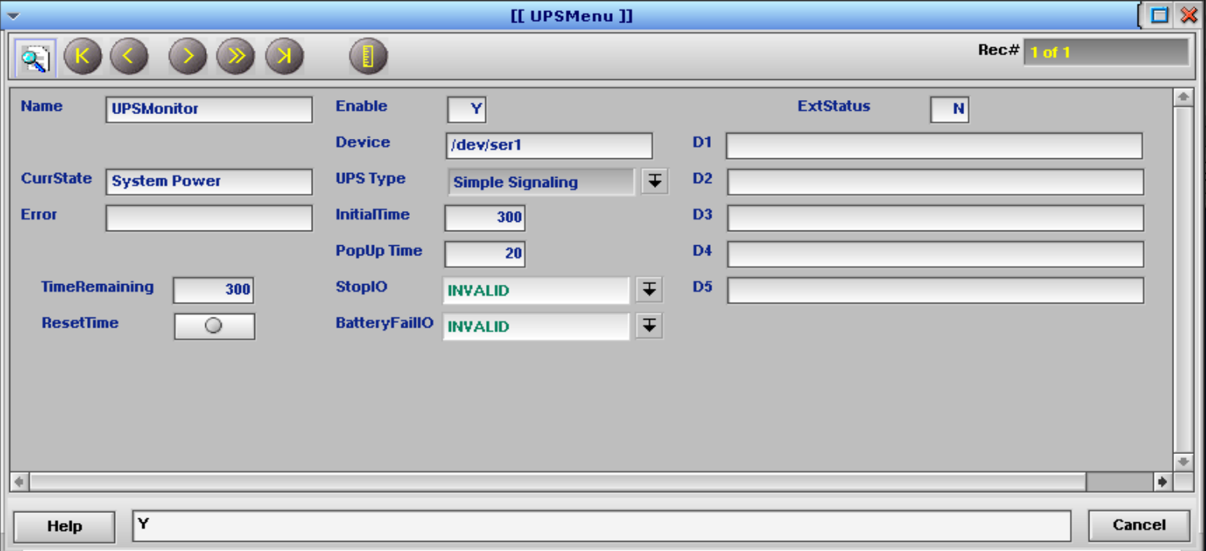

UPSMenu Screen
Column | Description | Value
Name | Give the screen a unique name. | UPSMonitor
Enable | Y – Enable the UPS monitoring process. The Batch job continues to run, but nothing happens.  N – Disable processing. Can be useful for troubleshooting. | Y
Device | Enter the QNX device name of the port to be used.  - Simple Signaling – Enter the serial port. Ex: /dev/ser1  - APC Smart Signaling – Enter the serial port. Ex: /dev/ser1  - CX2100-0904 – The port is automatically set to /dev/smb0  - CX2100-0914 – The port is automatically set to /dev/smb0  For APC Smart Signaling devices, the baud rate is set automatically. | Hardware dependent
UPS Type | Select the type of UPS interface.  - Simple Signaling - Used with the Legacy AP9620 Card.  - APC Smart Signaling - Used with the Smart UPS series.  - CX2100-0904 – Used with the Beckhoff power supply.  - CX2100-0914 – Used with the Beckhoff power supply. | See hardware above.
InitialTime | Set the time, in seconds, from the power fail event until a shutdown is initiated. If power is restored during this time, the time will be reset, and a shutdown will not occur. Once a shutdown is initiated, it must complete even if power is restored before it has completed. 300 seconds (5 minutes) is a good choice to avoid unnecessary shutdowns for short outages, but allow sufficient time to shut down cleanly before the battery expires. | 300
PopUp Time | Set the time, in seconds, until the UPSMenu screen is presented to the user. This serves as a visual indication to the user that a power loss has occurred, and allows action to be taken. Set this to 0 to disable the popup feature.  Note: The UPS will periodically test the battery and trigger a power loss event. If this time is set too short the client will see the popup about every 2 weeks due to the test.  20 seconds is a good value to avoid spurious popups for UPS tests and short outages. | 20
StopIO | Choose an output IO part here for uses such as triggering an Error or stopping the system. The output is fired when a power outage is detected. | Conveyor Part
BatteryFailIO | Choose an output IO part here to fire when a bad battery is detected by the UPS (APC Smart and Beckhoff only). Can be used to raise an Error. The UPS will only indicate a bad battery state for 5 minutes after a self-test. | Conveyor Part
CurrState | The current state reported by the UPS.  System Power – The system is running on line power.  Battery Power – The system is running on battery power or communication with the UPS has been lost.  Disabled – The module is not monitoring the power. | Calculated
Error | Addition information about the state of the UPS.  No Battery detection – Simple Signaling is set in the UPS Type and the BatteryFailIO has an entry. Simple signaling is unable to determine if the battery failed a self-test.  No self-test in 5 mins. – Not an error. The status of the battery cannot be determined.  None: SMART mode ON – Not an error. When using APC Smart Signaling the UPS monitor successfully turn on smart mode.  None: On AC – Not and error. The UPS told the Automation Control software it was not running on battery power.  Read Error – Unable to read data from the serial port. Verify the serial connection and cable type.
TimeRemaining | This value will be set by the module to the InitialTime value normally. If power is lost, the value will count down. When it reaches zero, the shutdown sequence will begin. You can use ResetTime to reset the value.
ResetTime | Click to reset TimeRemaining to the InitialTime value. | User Control
ExtStatus | Set to Y to activate extra status information for the Beckhoff UPS types. | Y
D1 – D5 | Extra status messages from the Beckhoff UPS types, if ExtStatus = Y. Possible values:  D1 – “Battery not connected”, “Battery connected”, “Battery connection unknown value 0xxxx”, “Get battery connection failed error nnnn”  D2 – “Battery needs to be changed”, “Battery is ok”, “Battery state unknown value 0xxxx”, “Get battery status failed error nnnn”  D3 – “Battery capacity nnn%”, “Get battery capacity failed error nnnn”  D4 – “Battery runtime nnnn seconds”, “Get battery capacity failed error nnnn”  D5 – “Power supply temp nnnC”, “Get temp failed error nnnn”
pTime | Used internally to record the time when a power event occurs, and to calculate how long the system has been running on battery.
pExtCode | Used internally to track battery states  -1 – Initialization state  0 – Running on AC power  1 – Running on battery power  2 – Power fail shutdown state  3 – Restart state for CX2100-09xx. Controls UPS monitoring.
pFileDesc | Used internally to access CX2100-09xx devices via /dev/smb0
pState | The internal state of the UPS module state machine.

Automatic Shutdown
When FPC is started the normal way, using Launch | FortnaPlus, a script found in the RUN directory called Start_UPS_Batch is called, which, in turn, calls script UPS_Batch. These two scripts, in addition to managing the way FPC is started, also work with the UPS module to shut down the QNX operating system if a power failure has been detected.
Once the UPS module determines it is time to shut the system down as the result of power loss, it will cause FPC to exit with a special code. This code is detected by the UPS_Batch script which calls functions to cause QNX to shut down.
When used with the APC Simple Signaling protocol, FPC will stop and QNX will be put into the “It is now safe for you to turn off your computer” state, but the AC power cannot be cut. The AC will continue to run until the UPS battery is exhausted. Note that if power is restored before this occurs, the AC will not go down, and manual intervention will be required to restore it to normal operation.
When used with the APC Smart Signaling protocol or the Beckhoff UPS models, the UPS module sends a command to the UPS just before going down to tell it to cut the power after some time – the default seems to be 90 seconds, probably configurable on the UPS.
NOTE: With APC Simple Signaling, if the communication cable is not connected, the UPS module will indicate the system is on “System Power”, though it doesn’t really know that.
NOTE: With APC Simple Signaling, if the configured serial port does not exist, the UPS module will report “Battery Power” and will count down and exit. This often happens when running a copy of an AC on a VM. Disable monitoring in UPSMenu but remember to enable it again if you install a version from your VM on real hardware!
NOTE: With APC Smart Signaling, if the communication cable is not connected, the UPS module will indicate “Battery Power” and will count down and exit. This often happens when running a copy of an AC on a VM. Disable monitoring in UPSMenu but remember to enable it again if you install a version from your VM on real hardware!

APC Bad Battery Detection
APC UPSes will perform a self-test every two weeks, by default. At the conclusion of the self-test, the APC Smart Signaling protocol will report the state of the battery for 5 minutes. The battery status will be reported in the UPSMenu_Error field. These are the possible values:
“No self test in 5 mins.” – A test has not been run recently.
“None: Battery good” – A test was passed recently.
“Battery Bad: capacity” – The battery is not holding a charge properly.
“Battery Bad: overload” – The battery cannot support the load.
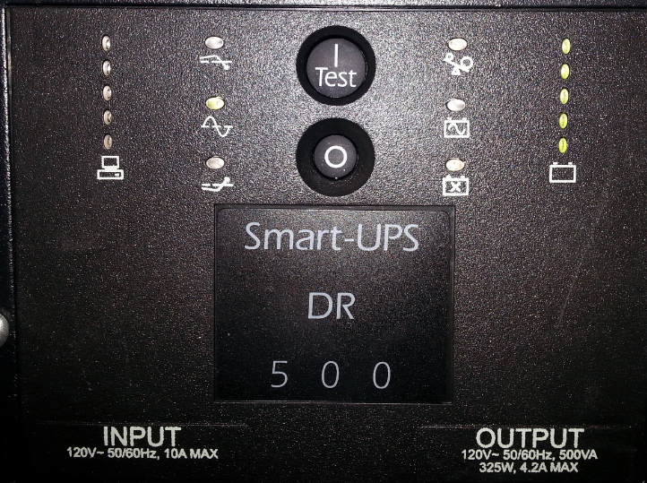
You can force a test by pushing the Test button on the UPS front panel.
NOTE: The APC Simple Signaling protocol cannot report the state of the battery. You must inspect the front panel of the UPS to determine the battery condition. Some models have a screen that will show a battery status message, some have indicator lights. If the pictogram of a battery with an X in it is lit, the battery is bad.

Logging
The UPS module logs power events to the MySQL database EventLog table (Operator Menu | Event Log) and to the GUI log file.
Message | Description
UPSMonitor: Power monitoring starting | The UPS Monitor preformed its startup initialization. If you do not see this message, verify that the UPS module is enabled in table Batches.
UPSMonitor: Power monitoring enabled | UPSMenu_Enable = Y and the communication port was successfully opened.
UPSMonitor: Power monitoring disabled | UPSMenu_Enable = N or the communication port is not properly configured or has an error.
UPSMonitor: On system power | The UPS is running on mains power.
UPSMonitor: On battery power | The UPS reports that it is running on battery power.  Note: This will also happen during a self-test.
Normal sequence of events for a power fail shutdown.
- Power is lost – Countdown begins in UPSMenu_TimeRemaining.
- UPSMenu_PopUp_Time seconds elapse – If a user is logged in, the UPSMenu will pop up on-screen.
- UPSMenu_TimeRemaining reaches 0 – APC Smart Signaling and Beckhoff UPSes are instructed to power off after 90 seconds. FPC saves data and shuts down.
- The UPS_Batch script executes the command to shut down QNX. The usual “It is now safe for you to turn off your computer” message is displayed. APC Smart and Beckhoff UPSes will power off after about 90 seconds. APC Simple UPSes will remain in this state until the battery is exhausted. If power is restored before that occurs, manual intervention will be required to restore normal operation.

Troubleshooting
Evidence of a power fail shutdown can be found in various logs:
MAIN log:
“Exit Processing (SMM_EXIT_REQ)”
GUI log:
“UPSMonitor: On battery power” when power is lost.
“UPSMonitor: SHUTTING DOWN FortnaPlus”
then normal shutdown messages, ending with “done all”.
/tmp/error:
Exit Code = 2
########################
Power Fail shutting down
########################
/var/log/syslog:
“syslogd: exiting on signal 15”
The table below is an attempt to define what will occur when UPSMenu is mis-configured:
UPS_Type | Port Condition – AC End | Port Condition – UPS End | CurrState
Simple Signaling | Open | N/A | System Power
Simple Signaling | Invalid port defined | N/A | Battery Power
Simple Signaling | Smart cable connected | Connected to UPS | Battery Power
Simple Signaling | Simple cable connected | Unconnected | System Power
Simple Signaling | Simple cable connected | Connected to UPS | Proper configuration – Will show System Power or Battery Power depending on actual state
APC Smart Signaling | Open | N/A | Battery Power
APC Smart Signaling | Smart cable connected | Connected to UPS | Proper configuration – Will show System Power or Battery Power depending on actual state
APC Smart Signaling | Smart cable connected | Unconnected | Battery Power
APC Smart Signaling | Simple cable connected | N/A | Battery Power
Note that if you use the wrong cable, it will detect it, but if you have a Simple Signaling model ,it doesn’t detect a disconnected cable – at either end! It also won’t detect if the Simple cable is plugged into the wrong serial port, as long as the defined port physically exists.
Make sure the configured serial port matches the physical port in use, and the cable is of the correct type to match the UPS and the UPSMenu_UPS_Type selected. Make sure the cable is plugged in at both ends.

Cable Wiring Diagrams
APC Simple Signaling:
